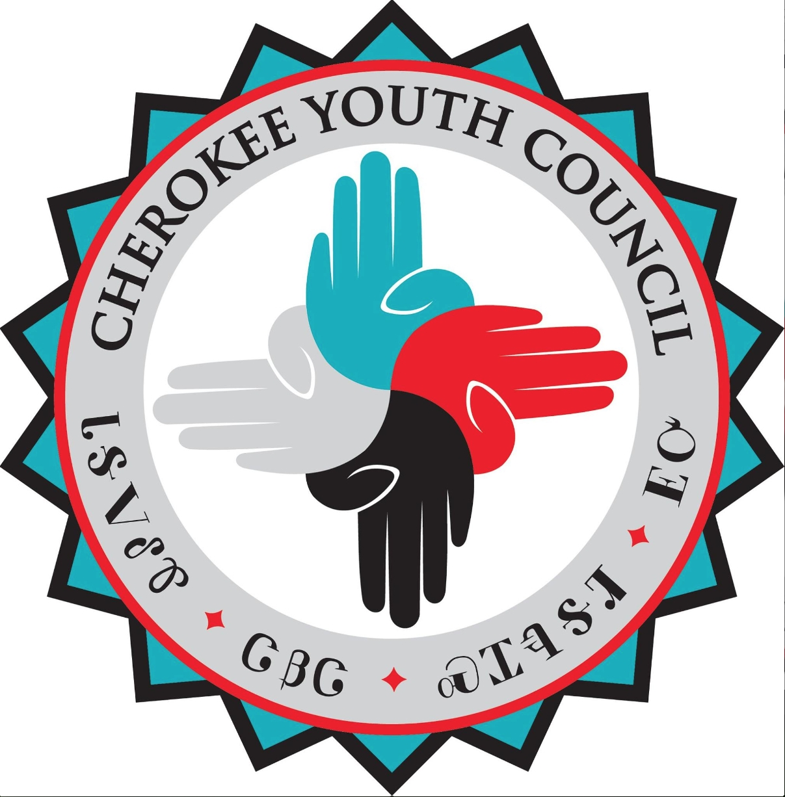

**CHRISTMAS GIVE BACK PROJECT**

**FAMILIES TO CHOOSE FROM**

**Family #1** : **Husband and Wife and two children**

***Wife***

Large t-shirt and large pants

Loves jewelry and purses

***Husband***

XL shirts and 34x30 pants

Need a watch, wallet, and socks size 10 1/2 and boxers size Men's small

Would love some tools, wrench set, tennis shoes size 10 1/2

***2 children***

**15-year-old boy**- size 40X46 pants and 2XL shirts

Loves you cars or remote control cars and pianos

Socks size 10 and boxers size XL

**19-year-old boy**- size 4XL pants and 3xl shirts

Loves to draw and paint and to bead

Needs sketch pads, socks size 14 wide

iTunes card or movies

Needs pot and pans and silverware set

_________________________________________________________________________________________

**Family #2 : Family of 10 people living in one home**

**4 Adults: 2 women**

***Women*** both 2xl shirts and shorts size medium and capris size 16 women

Loves Carolina shirts and Vaseline lotion, perfume bath and body works

***Men:*** Need jogging pants 2XL, Shirts 5XL / Likes Michigan State

Boot socks, Duke shirts size Large, Needs tool set

Family Needs: Pots and Pans and baking sheets and pans / Gain washing detergent

Family Wants: Toilet Paper and Paper Towels / Table and Chairs set

***6 children***

**2-year-old girl**-5/6 clothes size

Small Mickey Minnie or dinosaur figurines

Needs diapers size 6

**10-year-old girl**- size 12 clothes

Likes logos and dinosaurs, movies

**12-year-old girl**- size 16X pants and shirts Youth XL

iTunes cards, basketball, Carolina tar heels fan

**9-year-old boy**- size 8 pants and size 10 shirts

Dinosaurs, Legos, basketball, cheap phone or iPod to play games

**11-year-old boy**- size 14 pants and shirts size Youth large.

Likes basketball, scary movies

needs socks size 51/2

**13-year-old boy**-shirt size 18 and pants 16 juniors Huskey.

 likes basketball and football smoky mtn mustang shirts size or 18 juniors

Cheap cell phone

__________________________________________________________________________________________

**Family #3 : Grandma and three grandchildren**

***Grandma***

Size 14 Women’s pants and size large shirts

Needs Wool socks size 7-8

Needs a new queen bed set floral print mellow colors

Massage or manicure or food lion card

***3 children***

**15-year-old girl**- size 10/12 pants and medium shirts,

iTunes cards, native looking twin bed in a bag, girly hamper, native shirts, camera or Sd cards

**13-year-old boy**-size 32x28 pants and size large shirts

Loves Jordan shoes size 8

Needs duffle bag for sports

Needs minutes for straight talk and a full size plain bed set

**12-year-old boy**- size 6/8 junior’s pants and shirt size small in juniors

Twin native bedding set

Girly hamper, needs shirts

bras size 32 A and panties size 6 juniors

Loves music- google play card, phone minutes for T-Mobile phone.

_______________________________________________________________________________________

**DONATIONS for Dakota Pipeline at Standing Rock**

Gloves all sizes

Hats all sizes

Toothbrushes

Toothpaste

Shampoo & Conditioner Lotion

Body Wash Blankets

Bar Soap Board Games

Toilet Paper Gift cards

Paper Towels Gas cards

Pop Top Canned Foods x2

Socks for Girls and Boys

Microwavable foods

Candy

Chap stick